[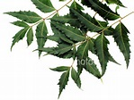](http://r.search.yahoo.com/_ylt=A9mSs2jM81ZZZAUA0zJjAQx.;_ylu=X3oDMTByZmVxM3N0BGNvbG8DaXIyBHBvcwMxBHZ0aWQDBHNlYwNzYw--/RV=2/RE=1498899532/RO=10/RU=http:/cqoj.typepad.com/vplla/nature/RK=1/RS=OswDwdGJkRDXaChUTk55CpnOFlw-)[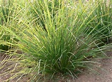](http://r.search.yahoo.com/_ylt=A9mSs2dx9FZZLwwAYFFjAQx.;_ylu=X3oDMTBybDA1bGNhBGNvbG8DaXIyBHBvcwMyBHZ0aWQDBHNlYwNzYw--/RV=2/RE=1498899697/RO=10/RU=http:/www.essentialoilspedia.com/vetiver/RK=1/RS=SSV.6DU2XdvF4eQ.hZCuL9vg7uo-) [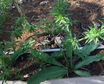](http://r.search.yahoo.com/_ylt=A9mSs3Jc9lZZu4IAYyFjAQx.;_ylu=X3oDMTByZmVxM3N0BGNvbG8DaXIyBHBvcwMxBHZ0aWQDBHNlYwNzYw--/RV=2/RE=1498900189/RO=10/RU=http:/sweetom.over-blog.com/2014/03/asseyons-nous-a-cote-de-eryngium-foetidum-ou-zeb-a-fe.html/RK=1/RS=1JiEP6Md5sBQl6UoQoFrm67qbL4-) [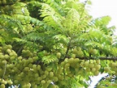](http://r.search.yahoo.com/_ylt=A9mSs2lp.lZZ4gYALoVjAQx.;_ylu=X3oDMTByZmVxM3N0BGNvbG8DaXIyBHBvcwMxBHZ0aWQDBHNlYwNzYw--/RV=2/RE=1498901225/RO=10/RU=http:/www.visoflora.com/photos-nature/photo-girembellier-phyllanthus-acidus.html/RK=1/RS=y2kHzNRLyvKn9f1xbbSMHRVq7Tw-)

Quelques Plantes originaires de l’Inde qui ornent le paysage foral guadeloupéen

VEPELE VETIVER ZEB A FE SURELLE

[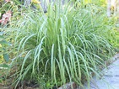](https://r.search.yahoo.com/_ylt=A9mSs3cM9VZZy2MA_XJjAQx.;_ylu=X3oDMTByZmVxM3N0BGNvbG8DaXIyBHBvcwMxBHZ0aWQDBHNlYwNzYw--/RV=2/RE=1498899852/RO=10/RU=https:/jardinage.ooreka.fr/plante/voir/699/citronnelle/RK=1/RS=JojjKSK6YCQeXC47OXAwRdtoZNU-) [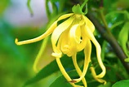](http://r.search.yahoo.com/_ylt=A9mSs2j39VZZo2QAX4ljAQx.;_ylu=X3oDMTByZmVxM3N0BGNvbG8DaXIyBHBvcwMxBHZ0aWQDBHNlYwNzYw--/RV=2/RE=1498900087/RO=10/RU=http:/aqua4balance.com/alternative-medicine/aromatherapy/essential-oils/ylang-ylang.html/RK=1/RS=kUER0K.4pvw8s7lATgpbHkHANc0-) [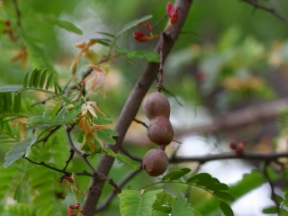](http://www.mi-aime-a-ou.com/photo_flore.php?id_img=6393) [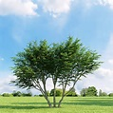](http://r.search.yahoo.com/_ylt=A9mSs3EB.1ZZR5gAzhJjAQx.;_ylu=X3oDMTByZmVxM3N0BGNvbG8DaXIyBHBvcwMxBHZ0aWQDBHNlYwNzYw--/RV=2/RE=1498901378/RO=10/RU=http:/www.plantes-et-nature.fr/33040-caragana-arborescens-caraganier-de-siberie-arbre-aux-pois.html/RK=1/RS=2FnjXQOVd4cmvfN.NajZHxvmOVU-)   
 CITRONNELLE YLANF – YLANG TAMARINIER POIS DE BOIS

[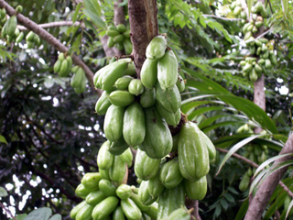](http://www.mi-aime-a-ou.com/photo_flore.php?id_img=5220) [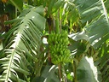](http://r.search.yahoo.com/_ylt=A9mSs3TF_FZZXagApypjAQx.;_ylu=X3oDMTByZmVxM3N0BGNvbG8DaXIyBHBvcwMxBHZ0aWQDBHNlYwNzYw--/RV=2/RE=1498901830/RO=10/RU=http:/creabracadabra.canalblog.com/albums/___sur_un_arbre_perche___/photos/32267657-bananier__senegal_.html/RK=1/RS=p.1frnwARdFaGUGEqi8bhgq7xEc-) [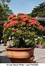](http://r.search.yahoo.com/_ylt=A9mSs2iK.1ZZREsA.bljAQx.;_ylu=X3oDMTByZmVxM3N0BGNvbG8DaXIyBHBvcwMxBHZ0aWQDBHNlYwNzYw--/RV=2/RE=1498901514/RO=10/RU=http:/canstockphoto.fr/les-grand-ixora-arbre-fleur-pot-17425309.html/RK=1/RS=aBZs1b6VD1Jtic7avVkiJiOxwNs-) 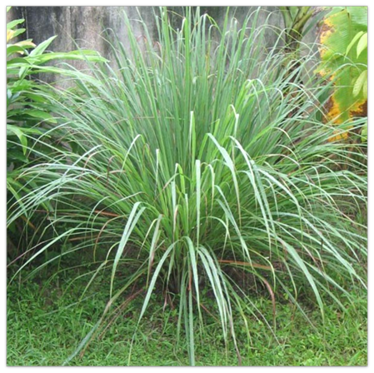   
 BELIMBI ou BELIMBE BANANIER IXORA VETIVER Page 1/2

[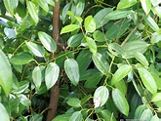](http://r.search.yahoo.com/_ylt=A9mSs27.SlhZ2nQAHD1jAQx.;_ylu=X3oDMTByZmVxM3N0BGNvbG8DaXIyBHBvcwMxBHZ0aWQDBHNlYwNzYw--/RV=2/RE=1498987390/RO=10/RU=http%3a%2f%2fwww.the-passion.fr%2fblog%2fles-bienfaits-sante-de-la-cannelle%2f/RK=1/RS=RorqJrMBoF9v84S6kRWCnmjSfIY-) [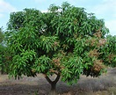](http://r.search.yahoo.com/_ylt=A9mSs2bES1hZEUMADBNjAQx.;_ylu=X3oDMTByZmVxM3N0BGNvbG8DaXIyBHBvcwMxBHZ0aWQDBHNlYwNzYw--/RV=2/RE=1498987589/RO=10/RU=http%3a%2f%2fcaribfruits.cirad.fr%2ffwi%2ffiche%3fnfich%3d160%26nomacc%3dma23/RK=1/RS=v.OnsKZ9qtEhHBGD5miEfo2hO0Y-) [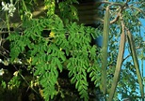](http://r.search.yahoo.com/_ylt=A9mSs2ohTFhZlW0ApoZjAQx.;_ylu=X3oDMTByZmVxM3N0BGNvbG8DaXIyBHBvcwMxBHZ0aWQDBHNlYwNzYw--/RV=2/RE=1498987682/RO=10/RU=http%3a%2f%2fwww.agrobenin.com%2fmille-et-une-raisons-dutiliser-le-moringa-oleifera-ou-larbre-de-vie-arzan-tiga%2f/RK=1/RS=LHaXytYGqh5wxjbMVqNxc_VXfV8-) [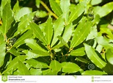](http://r.search.yahoo.com/_ylt=A9mSs3N5TFhZDasAFS9jAQx.;_ylu=X3oDMTByZmVxM3N0BGNvbG8DaXIyBHBvcwMxBHZ0aWQDBHNlYwNzYw--/RV=2/RE=1498987770/RO=10/RU=http%3a%2f%2ffr.dreamstime.com%2fphoto-stock-feuilles-d-arbre-de-laurier-%25c3%25a9pice-aromatique-image44741955/RK=1/RS=C9WAwFDIdhuf_lwwxYOK1A8k06I-)  
  
 CANNELLE MANGUIER MORINGA ou MOULOUGKILE TULSI

[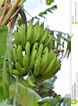](http://r.search.yahoo.com/_ylt=A9mSs2MbTVhZpGEASrFjAQx.;_ylu=X3oDMTByZmVxM3N0BGNvbG8DaXIyBHBvcwMxBHZ0aWQDBHNlYwNzYw--/RV=2/RE=1498987932/RO=10/RU=http%3a%2f%2ffr.dreamstime.com%2fphoto-stock-banane-sur-l-arbre-image57931502/RK=1/RS=wrpMtTO2O2y6tRpppwwwB88HBio-) [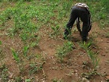](http://r.search.yahoo.com/_ylt=A9mSs3elTVhZ8qoALOhjAQx.;_ylu=X3oDMTByZmVxM3N0BGNvbG8DaXIyBHBvcwMxBHZ0aWQDBHNlYwNzYw--/RV=2/RE=1498988069/RO=10/RU=http%3a%2f%2fgoodboons.blogspot.com%2f2009%2f02%2farbres-clous-et-autres-merveilles-les.html/RK=1/RS=R5kdGfRzB0SkWuGzAcZAk9UWDPM-)[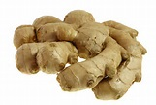](http://r.search.yahoo.com/_ylt=A9mSs3elTVhZ8qoALehjAQx.;_ylu=X3oDMTByZmVxM3N0BGNvbG8DaXIyBHBvcwMxBHZ0aWQDBHNlYwNzYw--/RV=2/RE=1498988069/RO=10/RU=http%3a%2f%2fboblechef.com%2finsolite%2f10-aliments-aphrodisiaques-meconnus-st-valentin/RK=1/RS=DVIkl9n2pY2RjOJGaHc3mH4ZsN4-)

BANANIER GINGEMBRE (Plantes) GINGEMBRE (Rhizome)

Page 2/2